Multi Observation Reality Tool and Interface

MORTI

**Research, Engineering, and Design Teams**



**University of Nebraska - Lincoln**

114 Othmer Hall/820 N 16th St.

P.O. Box 880642

Lincoln, Nebraska 68588-0642

**Team Contact**

Matthew Bigge

matthew.bigge@huskers.unl.edu

(402) 332-1910

**Team Members**

Matthew Bigge --- Team Lead

matthew.bigge@huskers.unl.edu --- Senior / Computer Science

Charlie McIver --- Product Manager

cmciver2@huskers.unl.edu --- Freshman / Computer Engineering

Michael DeJournett --- Outreach Coordinator

Mdejournett2@huskers.unl.edu --- Freshman / Software Engineering

Preston Ward — Tech Reviewer

pward6@huskers.unl.edu --- Freshman / Electrical Engineering

Joseph Seibel — Development Manager

jsebel2@husker.unl.edu — Freshman/ Computer Science

**Faculty Advisor**

Dr. Chris Bourke

chris.bourke@unl.edu

402-472-5008

Faculty Advisor Signature:  Date: 2022-10-30

Table of Contents

1. Technical Section .................................................................................................................. 3-12

a. Abstract .................................................................................................................................. 3

b. Software and Hardware Design Description .................................................................... 3

c. Concept of Operations (CONOPS)................................................................................... 6

d. Human-in-the-loop (HITL) testing .................................................................................... 7

e. Project Management........................................................................................................... 7

f. Technical References .......................................................................................................... 12

2. Outreach Section.....................................................................................................................13-

3. Administrative Section ........................................................................................................... 9

a. Institutional Letter of Endorsement.................................................................................... 9

b. Statement of Supervising Faculty ..................................................................................... 9

c. Statement of Rights of Use ................................................................................................ 9

d. Funding and Budget Statement ...................................................................................... 10

e. Hololens2 Loan Program................................................................................................... 11

f. Proposal Scoring Method.................................................................................................. 11

(Note: **The Technical Section is limited to 10 pages**. Include enough pictures within those 10 pages to describe your tool. If you want to submit many pictures, use an Appendix. Other sections and appendices **will not count against your 10-page limit.**)

**1. Technical Section**

a. Abstract

The abstract is a brief (up to 300 words) summary that touches upon the elements of the proposed prototype design and how they relate to the requirements and extravehicular activity (EVA) scenario in the Mission Description. Include any planned testing of the design and any proposed hardware or peripheral devices your team would bring to onsite testing.

MORTI, or Multi-Observation Reality Tool and Interface is a submission for the NASA SUITS challenge of 2022 from students from the University of Nebraska-Lincoln. MORTI, which is to be developed for the Microsoft Hololens 2 as per the challenge requirements, will assist astronauts on future EVA missions on the Lunar surface by providing an effective and efficient interface and user experience. It will assist in multiple tasks including: Navigation, Biometrics,

b. Software and Hardware Design Description

Include a detailed description of the proposed AR application and how you plan to tackle each aspect of the design challenge keeping in mind the context of the EVA scenario as stated in the Mission Description. Write in such a way a practicing engineer or scientist can understand the design of the user interface (UI). Present goals along with a description of the expected key components of the product (e.g., system architecture plan, hardware concepts, network diagrams etc.). Show conceptual UI design ideas (portrayed via wire frames, visuals, etc.) for navigation, telemetry, rover controls, geology, and EVA task instructions. Also show any peripheral device mockups (e.g., external control methods, lighting methods etc.) to help the technical reviewers understand the full scope of the proposed product. Be sure to highlight any unique solutions to the listed requirements your team is considering

1. Introduction

[Talk about Artemis missions future needs][why navigation is so dangerous on moon][efficiency and effectiveness of astronauts][other/previous solutions][introduce MORTI and why it's better than previous tools/procedures]

1. Navigation

The navigation system will work with a series of 3 dimensional coordinates facilitated by "Pins". Pins will be dropped at a regular interval, demarcating where the user has been and allowing them to be located. These pins will be viewable by the user, in AR, and on a miniature map. The pins can be made transparent or translucent with a wave of a hand, reducing intrusions on vision. Waypoints can also be added by pointing with finger after selecting a set pin option and choosing a pin type such as home, waymarkers, geological scanning locations or other points of interest. After a pin is created, a path can be constructed. This path will favor easy already traveled terrain that can be used to control a rover, or to create a path for a user to follow on foot. When navigating, a compass can be viewed that guides the user along the path that has been generated, eliminating the need to look at a bulky, sight-reducing map. Before entering a suit, a planned course can be pre-loaded from an outside computer. When they return from the EVA they can load all the data generated on the EVA onto a separate computer to be viewed and analyzed. Rovers can be remotely controlled from the minimap, utilizing the pathfinding feature to travel to and from points set by the user autonomously.

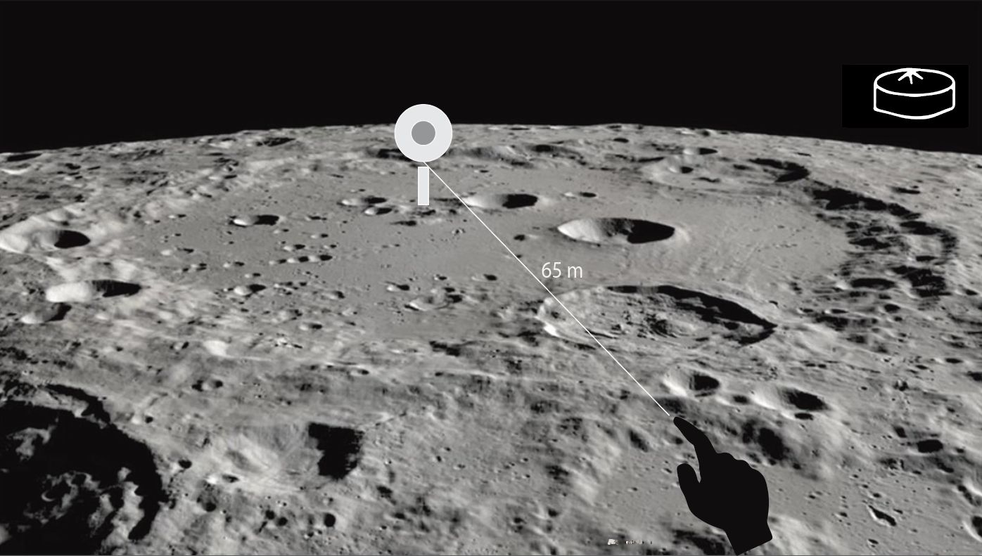

III. ROVER Controls/Interaction

The control system for the rover will be entirely directed from the user’s AR interface instead of a conventional joystick or controller. The rover will be controlled from a standstill in order to provide the most optimal control experience for the user. The control program will be initialized through a switch or button on an AR interface located on the user’s right wrist. The user can access the switch on the back of their wrist with their left hand. Once activated, there will be an initialization process to open the control program so that no other modules are activated. Once the user has the control interface activated, they will be provided a list of operations in order to select where they want the rover to go. The user will be able to select any of the provided pins within the navigation system and send the rover to the coordinates of the pin. The map provided within the navigation system will also give another camera view for the user controlling the rover. At all times, the AR interface will provide options to send the rover directly back to a home location. The home location will be placed by the user during the egress procedure. The rover will always be able to address its location relative to the user’s VISION kit and the home location.

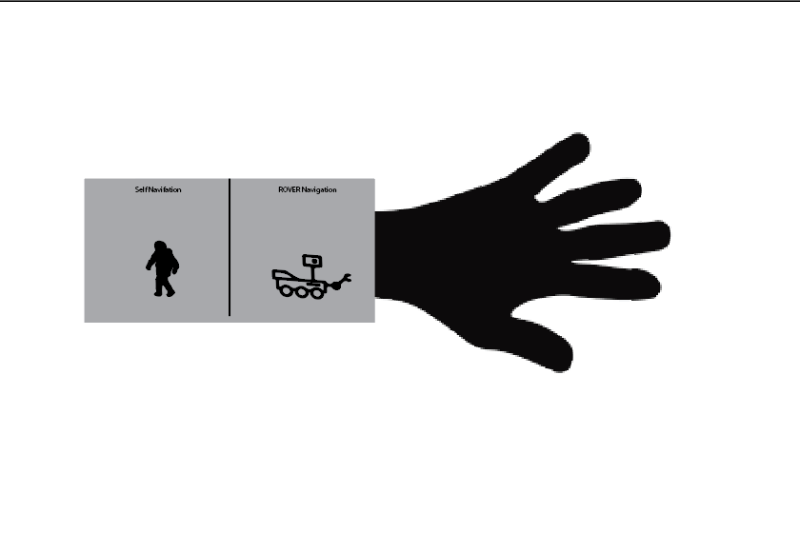

IV. Egress Procedure

Once the user puts on the AR headset, they enter a tutorial mode with a list of egress procedures. Text-based markers will appear in the AR scene with a checkbox next to each step. Once the user completes each task, they can tap the checkbox to move on to the next procedure. Prior to completing other tasks, the user must finish all of the egress procedures. The user then enters a mock airlock where they will be given a desired Umbilical Interface Assembly(UIA) configuration, and must flip switches to reach this configuration. The data from the UIA switches is connected to the telemetry system.

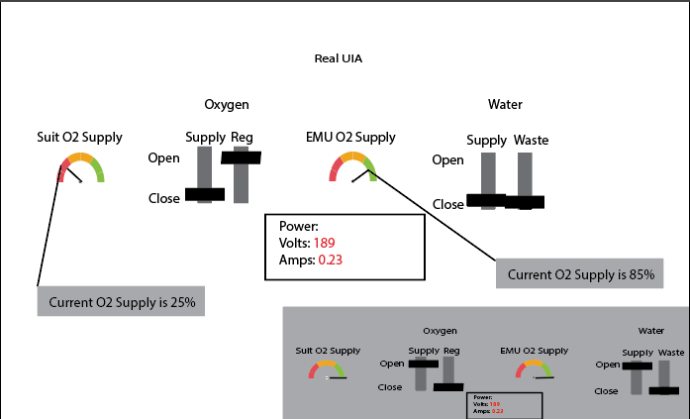

V. Geological Scanning

The tool will be able to scan the RFID codes found inside the rocks at the EVA site, then send the information to the suit, then display the information about the rocks in a small transparent bubble next to the rock. This data is then stored and can be accessed later to be processed and analyzed by an outside computer. A pin can be sent automatically to mark where the rock was retrieved. The pin setting system can also be used to mark the rocks for later retrieval.

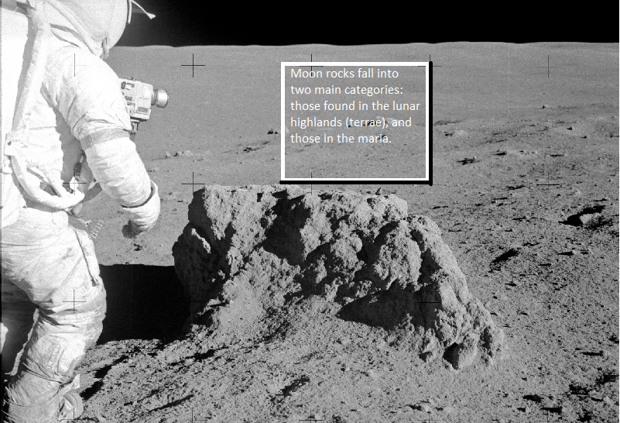

VI. Telemetry

Regarding the rover and the VISION kit, a display will always be provided to the AR user giving location data. The display will provide the latitude, longitude, altitude and bearing of the rover and VISION kit. The altitude and bearing will be relative to the home location created within the egress procedure. Alongside this another menu with the data from the spectrometer will be displayed. Any relevant data received from the spectrometer will be presented. The final set of information that will always be listed on the head mounted display is the biometrics of the VISION kit user. The biometrics will provide all the necessary information to ensure the safety of the user such as oxygen levels and temperature.

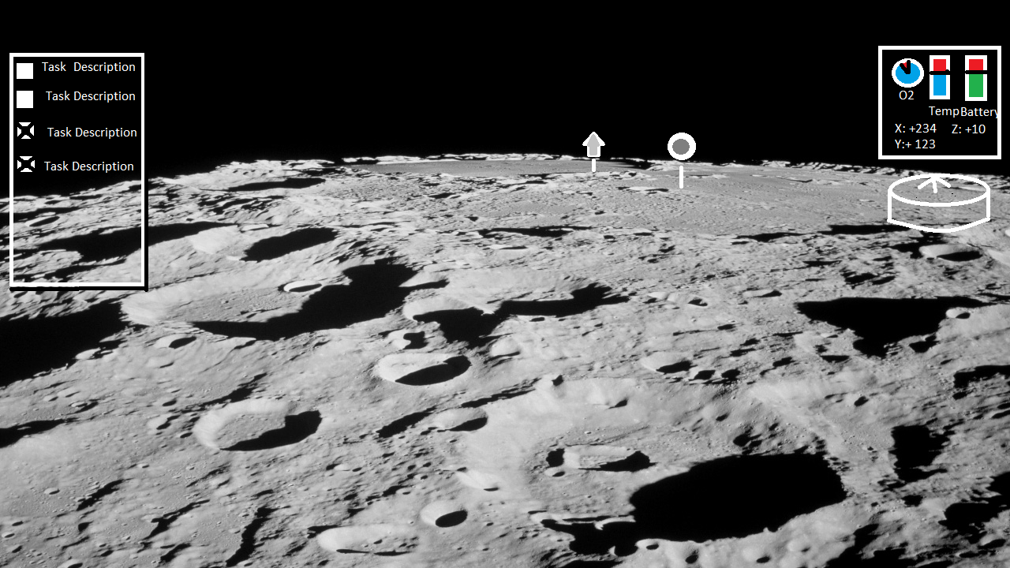

c. Concept of Operations (CONOPS)

The UI in this project will be designed using simple gestures and hand positions to allow for easy use. If the user struggles with hand gestures, they can press buttons displayed by the Hololens to operate the device. When the user leaves for the EVA the user will be presented with the simple switches and levers to adjust various UIA elements. Once that is completed and the user leaves for the EVA they will set a home pin by pointing and selecting a set pin option with the other hand. Similarly other types of pins can be set for POIs or "Breadcrumbs" by selecting a different option. Tasks are displayed in the FOV along with other vitals allowing for easy viewing, and a constant reminder of mission objectives and remaining time and resources. Telemetry data can be easily displayed as a floating text box, and can be disabled if bothersome. Rover Control can easily be managed from an arm menu allowing for easy travel between Pins. A convenient send rover home button will be placed as it will be needed often. All these features will allow the user easy access to every function, preventing awkward movements and wasted time. In the event that the gesture system becomes inoperable or bothersome, windows and buttons could be voice and sight manipulated, eliminating the need for one's hands to be free.

i. Navigation

When navigating, the user can set a waypoint by pointing at a spot in space. Once the waypoint is set, the headset displays a straight-line path and the distance to the waypoint. Once the user reaches the point, the waypoint disappears and the user can create a new waypoint. Additionally, the headset will display a compass that always points towards the shuttle as well as the distance from the shuttle. The user can also open up a map that displays a map of all required locations. The map shows the space shuttle, the users’ location, waypoints, the ROVER’s current location and the ROVER’s location objective.

ii. ROVER Controls/Interaction

The user can press a ROVER navigation mode on their arm. When the user enters the ROVER navigation mode, they can point to a location to set a waypoint–similar to user navigation–to determine the desired location for the ROVER. The waypoint will snap to a location within a reasonable distance of the user’s finger to account for dangerous terrain. After a waypoint is set, a marker appears on the minimap and the marker disappears when the ROVER arrives at the location.

iii. Egress

NASA outlines standard ingress-egress procedure as follows:

1. “Unstow and install MS seats. Install cooling units on the side of the seat.”
2. “If bioinstrumentation manifests, connect leads, cuffs, etc., as necessary, before donning suit.”
3. “Place the parachute on the seat.”
4. “Don suit and parachute harness.”
5. “Sit in assigned seat and connect parachute”
6. “Connect shoulder harness/lap belt.”
7. “Connect cooling.”
8. “Don comm cap and helmet.”
9. “Connect comm leads and orbiter O2 hose.”
10. “Don gloves, kneeboard, etc.”
11. “If bioinstrumentation manifests, make additional connections if necessary.”

The user will flip switches to reach the desired UIA configuration. After standard egress procedures are completed, the user will set a “Home Pin” which will determine the bearing for navigation. Once the astronaut completes these egress procedures, a mission statement will appear, dictating the required mission locations and tasks. After each mission task is completed, the task disappears and displays the next objective If this is the user’s first time going using the AR headset, they can enter a tutorial that explains the navigation, ROVER control, etc. with the headset.

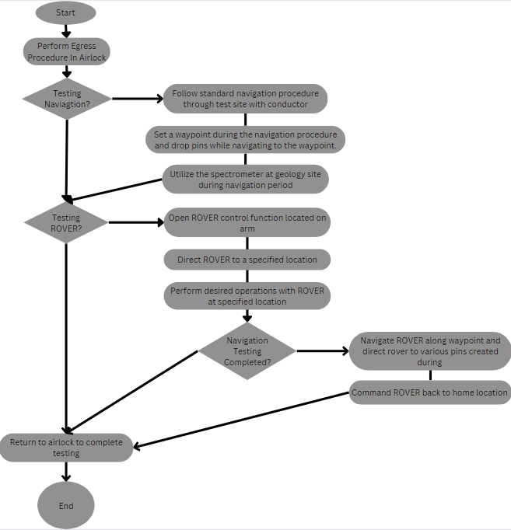

d. Human-in-the-loop (HITL) testing

Discuss any pilot, user experience, human-in-the-loop, or human factors studies planned. A written HITL test plan should include a testing schedule (including dates and times of planned testing), test protocol, possible metrics/measures, feasible subject pools, expected population/demographics of test subjects, and all planned safety measures to be used while conducting HITL tests. Include how the HITL test will inform your team’s development plan as they prepare for the analog EVA scenario, for example, planning for night/low-lighting testing, outdoor testing, and network/telemetry connection testing. A good HITL test plan will build towards a full test of the EVA scenario stated in the Mission Description before test week to identify any challenges ahead of the final test on-site.

During the sprints, all testing will be done internally. Tests of minor fixes and features will be conducted inside at a variety of locations at the university while end of sprint tests will be conducted in an environment more similar to the EVA scenario. After each sprint, testing will be conducted by a mixture of people familiar with the system as well as volunteers that have no experience. We believe that the volunteers with no experience with our system will help us find overlooked faults while those that have experience will be able to give us feedback on which features have improved and which have deteriorated since the last test. In these tests Volunteers will be provided with bulky clothing that will better imitate a space suit in order to get the most accurate results. Then, a member of the SUITS team will debrief volunteers by giving an overview of the objectives they are expected to complete and explaining basic hololens controls. Following the debrief, volunteers will be asked to attempt to complete all objectives without further human intervention. During the testing, data including time elapsed during the mission and what tasks were completed will be collected. This data will be useful in discovering the shortcomings of our solution. After each test, the participants will be asked for feedback on their experience. They will be asked to rate things such as ease of use, comfortability, UI design and explain why they gave it that rating. This will provide valuable insight into both the functionality of the software and the user experience. The tentative location for the end of sprint testing is the gravel parking lot next on Nebraska Innovation Campus. This location will allow us to partially emulate the rough terrain and low light quality that will be experienced at the Rock Yard. After our final sprint, a full EVA test will be conducted by both people experienced with the system and new volunteers. This final testing will serve to help pinpoint final changes and confirm all parts of the system function together. Our team will also consult with our mentor in order to gain more experienced input on both technical problems and design properties used in our solution.

Our projected testing dates are as follows*:

* Feb 6th: UI feedback
* Feb 20th: Navigation
* March 6th: Egress
* March 20th: Biometrics Data Stream
* Apr 17th: Rover Communication
* May 10th: Full EVA test

*The sprint schedule can also be seen in Section E

Each subsequent test following the first will include all previous portions in order to make sure that the new updates correctly integrate with previous versions.

e. Project Management

Provide an outline of the team’s development plans with any internal key milestones. Use a Gantt or similar chart. If following an Agile software development plan, outline your scrum schedule with a proposed feature development and testing plan. Describe how progress will be tracked to ensure that the requirements of the EVA scenario in the Mission Description are met ahead of test week. Teams are strongly encouraged to plan time throughout their development period to test their devices in conditions close to that of the described EVA scenario before traveling to Johnson for test week.

The project will utilize an Agile software development cycle. This cycle will consist of two 2 week sprints of development with a planned release every 1-1.5 months over the spring semester until testing week at Johnson Space Center. Each of these cycles will focus on 1-2 critical elements of the program, implementing them within that time period, with minor updates/bug fixes on other sections. Near the end of the cycle, testing will be conducted internally, then externally with the team’s advisor and outside participants. This testing will be handled by 2 team members while others finish outstanding issues and begin work on other critical elements. Once testing has concluded and the software has been approved, a release version will be created for further testing by the team and our NASA advisor. Each 2 week scrum will begin with a team planning meeting to decide what issues are critical and assign them to members. Then work will begin and continue throughout the two weeks, with issues being completed and tested internally. In the middle of each week of the scrum(twice within a 2 week sprint), a standup meeting will occur to determine what work has been completed and what needs more focus or help from others in order to be implemented. In the middle of each cycle, a member will be chosen to conduct grooming on the product backlog to make sure future scrums go as efficiently as possible. At the end of each scrum, a sprint review/retrospective will occur where the team will meet back together to discuss what went well and what didn’t, then they will take that forward into the next scrum period.

For the specific components of the software system, Base UI and Navigation is planned to be developed first as the other components will be largely influenced by these starting structures. The following development cycle from Feb to Mar will focus on the Egress Procedure & Biometrics Display system. The last cycle from Mar to Apr will focus on ROVER Controls and Geological Scanning. The last 3 weeks before testing week are planned to be one development period focused on bug fixes and project optimization. With three weeks planned extra for only bug fixes and optimization, not critical elements, it will give the team a buffer of time if it is deemed necessary to extend a cycle by a week to stay within the timeline. 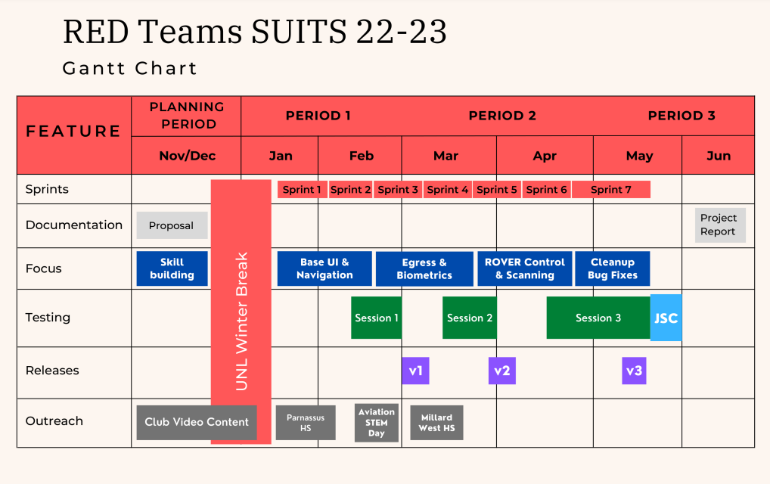

The team will use Github as the online repository for development. This software allows members to create their own branches/versions of the program to easily let multiple features be worked on at the same time with little to no conflicts. The team will implement a redundant branch structure to ensure software integrity and quality, utilizing a development branch system to ensure bugs and errors are not present in the monthly testing as per the project timeline above. From this development branch, team members will branch off to work on specific issues and concepts as planned from the Zenhub issue board integrated into our project repository.

As a team, we will be tracking development via ZenHub, an issue tracking software with web-based integrations in Github. This software will let the team better track many aspects of the project as they develop it. Each major section of the project is assigned as an Epic, or a grouping of issues. These issues will follow a set of pipelines being: New Issues, Grooming Required, Product Backlog, Sprint Backlog, In Progress, Internal QA/Review, Advisor QA/Review, Done, then Closed. The issues that follow this production pipeline will be fleshed out with time estimates, completion requirements, development labels such as UI or environment, and which sprints/releases it is associated with. Once issues are groomed and the sprint they are associated with arrives, team members will work on issues they chose or have been assigned. As project work continues, members will create new issues as problems and new concepts are implemented or planned. By doing these tasks with the Zenhub Board, the team will be more organized and strategic in our software development cycle.

The Architecture of the system is planned to all stem from the user interactions within the Hololens User Interface, using the hand and eye tracking inorder to traverse the menus and select which tools to use within the system. Unity isn’t organized the same way visually as basic programs students would make in C or Java, with a cascading file structure, instead it is developed with objects in the environment having scripts attached to them and interactions take place between them and/or the player. Despite this, the team felt it appropriate to utilize a UML Diagram to organize and display how the system components will interact with one another.

UML Diagram of features:

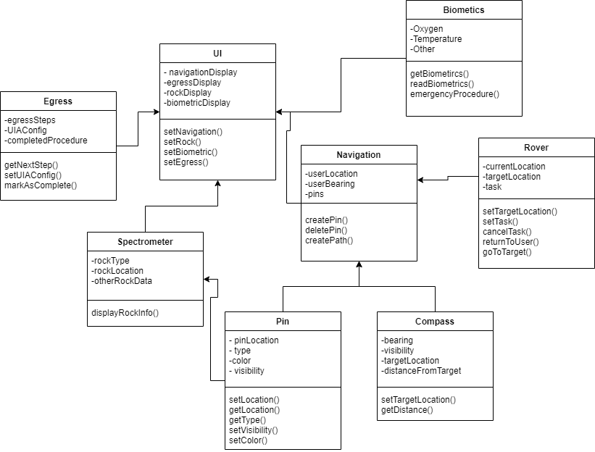

Proposal Submission: Nov 1st

From Nov 1st - Dec 8th: Team works on getting experience in Unity/C#, further planning features/architecture and UI, conduct Outreach Events

Dec 8th: Selection Announcement

Dec 8th - Jan 23rd: As it occurs over the Schools Winter break the Team will continue development of Unity Skills, and begin work on projects with basic systems in UNITY and getting acquainted with how Hololens development in Unity works best.

Development Schedule: Two Week sprints with 1-1.5 Month development and release schedules, focusing on one major feature in each with minor work on other parts in terms of UI design and architecture

Jan 23rd-Feb 6th then Feb 6th-20th: Work on major functions of UI and Navigation

Feb 20th-Mar 6th and Mar 6th-20th: Egress Procedure and Biometrics

Mar 20th-Apr 3rd and Apr 3rd-17th: Rover Navigation

Apr 17th-May 10th: Work on outlying features, bugs, cleaning up

May 17-May 24th: Travel for Testing Week in Houston at Johnson Space Center

f. Technical References

Coldiron, L., Flagan, A., & Alexander, J. (2005, January 17). Crew Escape Systems 21002. https://www.nasa.gov/centers/johnson/pdf/383443main_crew_escape_workbook.pdf

Cite referenced works in text and in a “References” section using formatting appropriate in a technical paper.

**2. Outreach Section**

The outreach section of the proposal includes the team's plan for disseminating the results of their experiment/experience to the public. Information contained in this section should focus on the outreach activities the team intends to implement and the target audience to address. The outreach plans must be original to the team. **Do not post original proposal documents on any social media platforms or channels.**

A plan is an organized way to achieve a specific objective. Random activities, even good random activities, do not constitute a plan. An outreach plan should have two major components:

• The **plan** – a description of the team’s objectives and goals; what activities are planned for the upcoming year; where and when the activities will take place; what audience is targeted, etc.

• The **activities** – what will the team do when they get there? What materials will they refer to? What are the main points that they will make?

For maximum point value, the plan should include the following:

• The team’s objectives for each outreach activity.

• A description of the outreach audience (K-12 class or school groups, undergraduate research symposiums, university outreach to local schools, informal groups such as Boy/Girl Scouts, after school clubs, church groups).

• Specific plans for activities (strengthened by alignment to state or national standards will help a K-12 teacher, use of the 5E Model, or use of age/grade appropriate language during the activity). Leading an “Hour of Code” in a classroom is the optimal outreach activity.

• Letters or agreements from institutions who accept your invitation to address their group.

• A press and/or social media plan.

• A connection between curriculum/activity and NASA SUITS, a NASA Mission, Informatics and Subsystems team at Johnson, or the team’s code.

The University of Nebraska-Lincoln’s Research Engineering and Design team is committed to promoting the fields of science, technology, engineering, and mathematics (STEM) within the local community. Providing younger students early exposure to the incredible possibilities available to them in the fields of Science, Technology, Engineering, and Mathematics is a rewarding goal. All members of our specific NASA Micro-g NExT team are passionate advocates for this aim. Historically, the club has attended science fairs and visited classrooms to promote NASA, STEM, and UNL.

The club has an overall social media plan in place for the upcoming school year with previously created Twitter/Instagram accounts to announce project statuses or events and planned video content on Youtube to show off the various projects’ developments and some of the skills. The plan for using typical social media platforms is to use them as a forum to announce our progress and point out specific events, such as testing week or project milestones. Over the last year, this has served the club well as a way to keep students that are not involved in the club interested in the project's progress and NASA research. The planned Youtube content is primarily going to be explanations of the club's previous projects(Micro-G 2022 and prior) and videos discussing the various tools and skills we use to develop our NASA student challenges. These videos will be targeted towards a middle to high-school aged audience in order to raise awareness and interest in NASA.

As a club, R.E.D. Teams attended the large-scale campus outreach event on September 1st. This event, called Rock the Block, is dedicated to welcoming UNL engineering students back from the summer. Additionally, Rock the Block provides engineering clubs with opportunities to engage new members and raise awareness for their goals. Over 1,100 engineering students were in attendance and R.E.D. Teams was able to recruit 32 new members. As a relatively new engineering club, this event was critical in gaining good exposure to the UNL College of Engineering student body, as well as raising awareness and interest in NASA.

Another university hosted event the team attended was the School of Computing club fair held by the Computing Student Advisory Board(CSAB) on October 10th. This event allowed targeted recruitment and outreach for the SUITS program towards UNL Computing students. The objective of this event was not only to acquire more prospective team members for the submission, but also to promote NASA and aerospace research. The materials used for this event were the club’s previous years submissions to the NASA Micro-g NeXT and Big Idea Challenges as completed challenges along with the mission description for the 22-23 SUITS Challenge.

Multiple High-School targeted outreach events are planned for the coming year. The team has two presentations planned with their previous high-school teachers to present the

| Type/Name | Location | Date | Target Audience | Description |
| --- | --- | --- | --- | --- |
| High School Presentations | Parnassus Preparatory School, MN | January 2023 | High-School Classes | Opportunity to engage with a small set of students out of state via video call. One on one engagement with students and the ability to provide in depth details about the SUITS program. |
| Millard West High School, Omaha NE | March 2023 | Presentation of SUITS Project development and other NASA activities. Engaged students with basic software engineering activity. |
| Lincoln Area Public High School  (TBD) | Spring 2023 | Lincoln Science Focus Program Students | The club is currently in communications with the department chair of the LPS Science Focus Program. This program provides a selective community of students participation in various styles of learning to better define their education and learning environment. Our goal is to present our SUITS project to one of their STEM classes, as well as engage the students in a related activity. |
| Rock the Block | UNL Vine Street Fields | 09/01/22 | UNL undergraduate engineering students | Large-Scale campus outreach event to welcome UNL engineering students. Opportunity to engage with and promote NASA projects to prospective students. |
| Computing Student Advisory Board Club Fair | UNL Schorr Center of Computing | 10/10/22 | UNL School of Computing Students | Outreach event specifically targeted at Computer Science, Software Engineering, and Computer Engineering students. Opportunity to engage with and promote NASA research and design projects with prospective students. |
| Aviation STEM Day | Oakview Mall | 2/18/23 | 6th-12th Grade students in the Omaha Metro | STEM event in Omaha area shopping mall directed towards 11-18 year old students to display diverse careers within the Aviation/Aerospace industries. Our purpose here is to introduce younger audiences to our missions, along with promoting NASA related activities. |
| SAC Museum Show Day | SAC Air and Space Museum | Spring 2023 | K-12 Students in the Omaha/Lincoln Areas | We plan to host a booth at the SAC museum in Ashland NE for R.E.D. Teams NASA projects once again this academic year during one of their K-12 STEM events. In the past this event has a been a great way to introduce young audiences of our project and to promote NASA related activities |
| 4H Event on Campus | UNL Engineering Department | Spring 2023 | Lincoln Area 4H Students | 4H Student targeted event where a small group of students will be given a tour of the facilities in the College of Engineering and then presented with RED Teams NASA challenge projects such as this one, followed by an engineering activity. |
| Social Media | Online | Continuous | High School and Collegiate Students | Postings of updates of team and NASA achievements on Twitter and Instagram platforms. |

**3. Administrative Section**

a. Institutional Letter of Endorsement

Reference Appendix A

b. Statement of Supervising Faculty

Reference Appendix B

c. Statement of Rights of Use

As a team member for a proposal entitled “MORTI” proposed by a team of higher education students from the University of Nebraska-Lincoln, I will and hereby grant the U.S. Government a royalty-free, nonexclusive and irrevocable license to use, reproduce, distribute (including distribution by transmission) to the public, perform publicly, prepare derivative works, and display publicly, any technical data contained in this proposal in whole or in part and in any manner for federal purposes and to have or permit others to do so for federal purposes only. Further, with respect to all computer software designated by NASA to be released as open source which is first produced or delivered under this proposal and subsequent collaboration, if selected, shall be delivered with unlimited and unrestricted rights so as to permit further distribution as open source. For purposes of defining the rights in such computer software, “computer software” shall include source codes, object codes, executables, ancillary files, and any and all documentation related to any computer program or similar set of instructions delivered in association with this collaboration.

As a team member for a proposal entitled “MORTI” proposed by a team of higher education students from the University of Nebraska-Lincoln institution, I will and hereby do grant the U.S. Government a nonexclusive, non transferable, irrevocable, paid-up license to practice or have practiced for or on behalf of the United States Government any invention described or made part of this proposal throughout the world.

*Reference Appendix D for signatures.*

d. Funding and Budget Statement

**Items Costs**

***Table 1: Draft Budget***

| Category | Item | Cost | Description |
| --- | --- | --- | --- |
| Travel Expenses | Hotel | $1,000.00 | 2 rooms for 5 people for 5 days |
| Van Rental & Gasoline | $750.00 | Driving from Lincoln, NE to Houston, TX and travel within Houston |
| Food | $500.00 | Food for 5 people for 5 days |
| Development Software(s) and Tools | CI/CD integration Software | $250.00 | Continuous Integration software for Unity development |
| Technology | Microsoft Hololens | $3,500.00 | Microsoft Hololens 2 for project development. (if Hololens is provided by NASA/University once accepted, this funding will be redistributed/removed) |
| Misc. Operating Costs | Outreach Events | $250.00 | Funding for travel and materials associated with outreach events |
| Total Amount: | Total Cost: | $3750.00 |  |

***Table: 2 Funding and Sponsorships***

| Source of Funding | Source Category | Amount | Description |
| --- | --- | --- | --- |
| UNL Engineering Advisory Board(eSAB) | Funding from the UNL College of Engineering | ~$3,000.00 | Funding must be used by the end of Summer, and can be dedicated to materials, licenses and travel expenses. Funding to be requested in Spring 2023, with a requested amount of $3000 for project expenses and travel. |
| NASA Nebraska Space Grant | NASA | TBD | R.E.D. Teams have applied for and received a grant for materials, tools, and travel. |
| Glow Big Red Fundraiser | University-Sponsored fundraiser | $250.00 | Funding dedicated to purchasing of club apparel and outreach |
| NASA Milestone Stipend | NASA | $1,000.00 | Estimation from previous stipends awarded to other student design programs like NASA Micro-G NeXT, which offer an assistive stipend for hitting milestones on time. Will be used to fund lodging. |
| Honeybee Robotics | Industry Sponsor | TBD | Will be providing a monetary donation, along with technical advice. |
| Total Amount: |  | $4,250.00 |  |

e. Hololens2 Loan Program

NASA SUITS has a limited number of Hololens2 devices we can loan to institutions. Please indicate your interest in a loaned device:

A) We do not require a loaned device because we either already have one, or plan to acquire one.

B) We need a loaned device from NASA SUITS to participate.

C) We have a device but would still like to be considered for a loan to aid in our development.

B.) We need a loaned device from NASA SUITS to participate.

We will request the university for support in borrowing a device and/or seek funding to purchase the club its own; however, this is not guaranteed due to the price of the equipment necessary and the university’s usage of this equipment for course projects and research. Thus, we request a device from the NASA SUITS program to assure that we will have the proper equipment to develop our proposal if accepted.

f. Proposal Scoring Method

A scoring rubric, provided below, with required criteria will evaluate how well a proposal addresses each of the following required components: technical merit, outreach plan, and adherence to all proposal requirements.

Teams selected to build designs for NASA SUITS will create a first-person point of view video of their UIs in action along with their code, during the software design reviews occurring in April 2023. Teams are also required to submit a draft of a white paper illustrating the development of their visual information display system upon completion of the NASA SUITS challenge.

**4. Appendices**

1. **Institutional Letter of Endorsement**

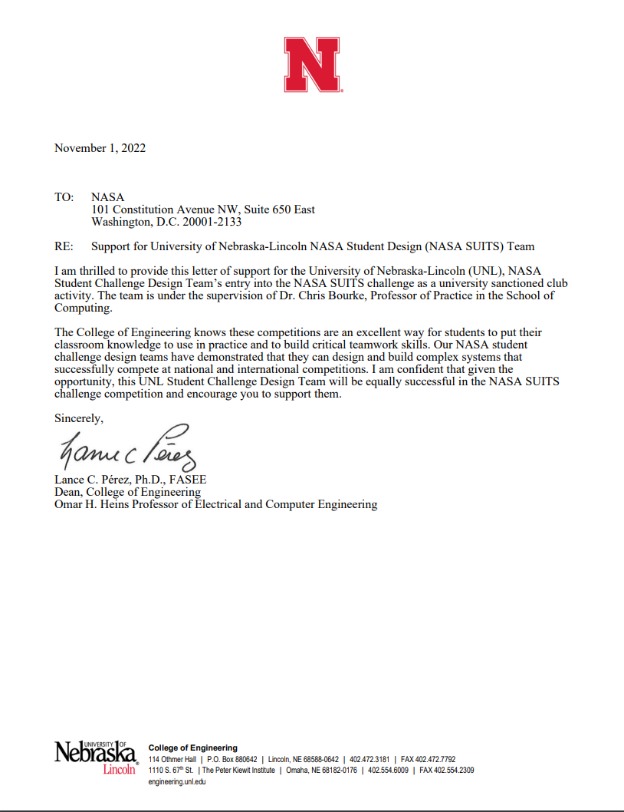

1. **Statement of Supervising Faculty**

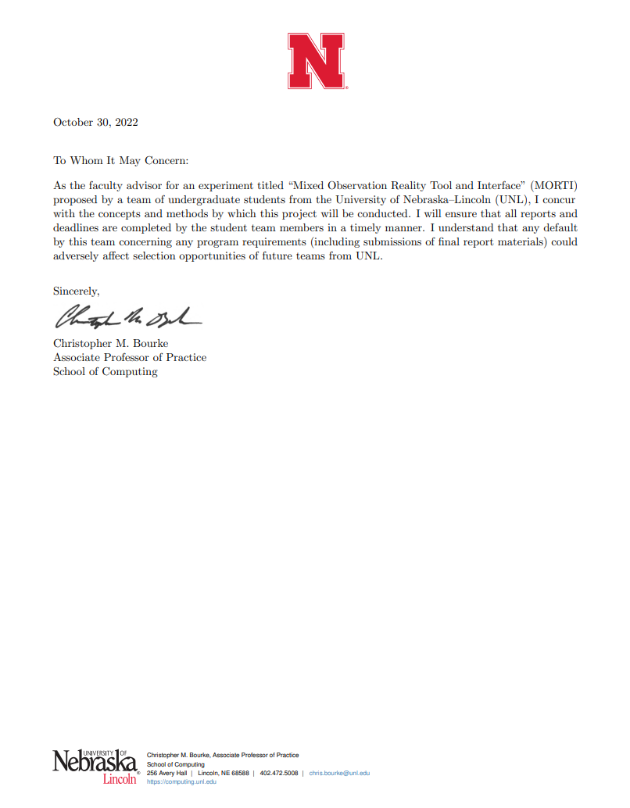

1. **Statement of Rights of Use Signatures**

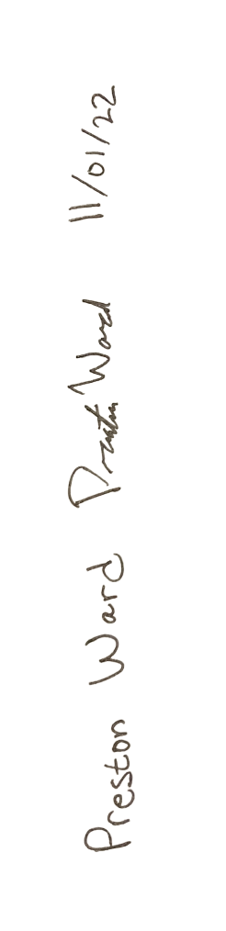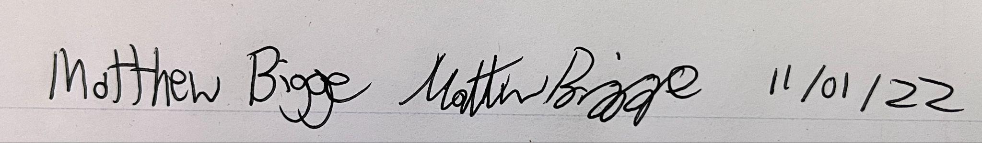

Chris Bourke  Date: 2022-11-1



